BLOODGROUP DETECTION USING FINGERPRINT

WITH IMAGE PROCESSING TECHNIQUE

A PROJECT REPORT

Submitted by

J.S.MARYAM SHAFA | 311821104024
VISHALI.S | 311821104060
KARISHMA.W | 311821104015

In partial fulfillment for the award of the degree
of

BACHELOR OF ENGINEERING
IN

COMPUTER SCIENCE AND ENGINEERING

MOHAMED SATHAK AJ COLLEGE OF ENGINEERING


ANNA UNIVERSITY : CHENNAI 600 025

JUNE 2025

ANNA UNIVERSITY : CHENNAI 600 025

BONAFIDE CERTIFICATE
Certified that this project report “BLOOD GROUP DETECTION USING FINGERPRINT” is the bonafide work of “J.S.MARYAM SHAFA (311821104024) , VISHALI.S (311821104060) , KARISHMA.W (311821104015) "who carried out the project work under my supervision.

Mr. S.VIMALATHITHAN | Mr. S.VIMALATHITHAN
HEAD OF DEPARTMENT | SUPERVISOR
Department of Computer Science and Engineering | Department of Computer Science and Engineering
Mohamed Sathak AJ College of Engineering | Mohamed Sathak AJ College of Engineering
Siruseri,Chennai-603103 | Siruseri,Chennai-603103

Submitted for the project viva voce examination held on

INTERNALEXAMINER | EXTERNALEXAMINER

ACKNOWLEDGEMENT
We extend our deepest gratitude to the Divine for the unwavering guidance and strength bestowed upon us, enabling the successful completion of this project. Our heartfelt appreciation goes to OUR PARENTS, whose enduring support has been the cornerstone of our journey throughout this project and our academic pursuits. We express our profound thanks to ALHAJ JANAB S.M. YOUSUF, Chairman,and MR. MOHAMED SATHAK, Director, of Mohammed Sathak A J College of Engineering, Chennai, for their visionary leadership and support. Our sincere gratitude is directed towards our esteemedPrincipal, DR. K. S. SRINIVASAN, for granting us the opportunity to carry out our project within the nurturing environment of our college.Special thanks are due to our Head of the Department and our Project Coordinator, MR. S VIMALATHITHAN, Assistant Professor, Department of Computer Science and Engineering, whose mentorship and insights have been invaluable. We would also like to acknowledge the collective efforts of all faculty members and staff of the Department of Computer Science and Engineering.Their support has been instrumental throughout our academic journey. Lastly, we are thankful to our friends.

ABSTRACT.
Blood group determination is a fundamental requirement in medical practices such as transfusions, emergency care, and organ transplants. Traditional methods rely on invasive blood sampling and laboratory testing, which can be time-consuming, resource-dependent, and inaccessible in remote or emergency scenarios. This project introduces a novel, image-based approach to blood group prediction using fingerprint analysis.
The system utilizes a convolutional neural network (CNN) model trained on a publicly available fingerprint dataset sourced from Kaggle. Advanced image processing techniques—including resizing, normalization, and data augmentation—are applied to prepare the data. The model is developed and trained using GoogleColab with TensorFlow and Keras libraries, achieving classification across all eight major blood groups (A+, A−, B+, B−, AB+, AB−, O+, O−).
The application’s backend is implemented using Python Flask, which provides aRESTAPIforpredictingbloodgroupsbased onuser-uploaded fingerprint images. A React.js-based frontend allows users to interactwith the system, and the predictions are stored using a Node.js service with a MySQL database.

This method offers a non-invasive, quick, and portable solution for blood group detection, making it especially valuable in low-resource settings. While the system does not perform biometric identification, it leverages fingerprint image features solely for classification purposes, offering a simplified and scalable alternative to traditional testing methods

LISTOFTABLES

TABLENO | NAME | PAGENO.
4.1 | Hardware requirements specification | 17
4.2 | Libraries and tools purposes | 19

LIST OF FIGURES

FIGURENO. | NAME | PAGENO.
5.1 | Use case Diagram | 23
5.2 | Class Diagram | 24
5.3 | Sequence Diagram | 25
5.4 | Component Diagram | 26
5.5 | State machine diagram | 27

TABLEOFCONTENTS

CHAPTERNO. | TITLE | PAGENO.
 | ABSTRACT | I
 | LISTOFTABLES | III
 | LISTOFFIGURES | IV
1. | INTRODUCTION | 1
 | 1.1 BACKGROUND | 1
 | 1.2 PROJECT REVIEW | 1
 | 1.3 PROBLEM STATEMENT | 2
 | 1.4 OBJECTIVES | 2
 | 1.5 SCOPE OF WORK | 2
 | 1.6 METHEDOLOGY | 3
2. | LITERATUREREVIEW | 4
 | 2.1 BLOOD GROUP DETECTION USING IMAGE PROCESSING AND DEEP LEARNING | 5
 | 2.2 CORRELATION OF BLOOD AND LIFESTYLE. | 6
 | 2.3 BLOODGROUP DETECTION USING FINGERPRINT | 8
3. | SYSTEMSTUDY | 8
 | 3.1 EXISTINGSYSTEM | 8
 | 3.2 PROPOSEDSYSTEM | 9
 | 3.3 COMPARISON TABLE | 9
 | 3.4 ADVANTAGES OF PROPOSED  SYSTEM | 12
4. | SYSTEM REQUIREMENTS | 12
 | 4.1 HARDWARE REQUIREMENT | 13
 | 4.2 SOFTWARE  REQUIREMENTS | 13
 | 4.2.1 Operating System | 13
 | 4.2.2 Libraries and framework | 14
 | 4.2.3 Development environment | 16
5. | SYSTEM DESIGN | 16
 | - 1 UML DIAGRAMS | 16
 | - 1 Use case diagram | 17
 | 5.1.2 Class diagram | 18
 | 5.1.3 Sequence diagram | 18
 | 5.1.4 Component Diagram | 20
 | 5.1.5State machine Diagram | 21
6. | SYSTEM IMPLEMENTATION | 21
 | 6.1 MODULE DESCRIPTION | 21
 | 6.1.1 Fingerprint Scanning  module | 22
 | 6.1.2 Preprocessing module | 22
 | 6.1.3 Feature Extraction  Module | 23
 | 6.1.4 Machine learning module | 24
 | 6.1.5 Matching and verification  module | 25
 | 6.1.6 User interface module | 25
 | 6.1.7 Database management  Module | 26
 | 6.1.8 Scalability module | 26
 | 6.1.9 Testing Module | 27
 | 6.1.10 Deployment module | 28
7. | SYSTEM TESTING | 28
 | 7.1 OBJECTIVE OF SYSTEM  TESTING | 28
 | 7.2 TESTING ENVIRONMENT | 29
 | 7.3 TEST CASE FLOW  DESCRIPTION | 29
 | 7.4 UNIT TESTING | 30
 | 7.5 INTEGRATION TESTING | 30
 | 7.6 PREFERENCE TESTING | 31
 | 7.7 VALIDATION TESTING | 31
 | 7.8 ERROR HANDLING AND  ROBUSTNESS TESTING | 32
 | 7.9 USER EXPERIENCE AND  INTERFACE TESTING | 32
8. | CONCLUSION | 33
9. | APPENDIX | 34
 | A : SOURCE CODE | 34
 | B : SCREENSHOT | 54
10. | REFERENCES | 58

CHAPTER - 1
INTRODUCTION

1.1 BACKGROUND
Blood group determination is essential in numerous medical situations, including blood transfusions, surgeries, and emergency treatments. Traditionally, this process involves serological testing, where blood samples are drawn and analyzed using antigen-antibody reactions. While accurate, this approach is invasive, time-consuming, and dependent on clinical infrastructure. In rural or resource-limited areas, such testing can be delayed or inaccessible.
With the rise of artificial intelligence and image processing technologies, researchers have begun exploring non-invasive alternatives. Among these, fingerprint analysis has shown potential due to the uniqueness and availability of fingerprint patterns. This project investigates the feasibility of predicting blood groups using fingerprint images, eliminating the need for blood collection and laboratory testing.

1.2 PROJECT REVIEW
Previous research has indicated possible correlations between fingerprint ridge patterns and blood groups. Studies have applied both traditional image processing methods and modern deep learning models such as Convolutional Neural Networks (CNNs) to classify fingerprint images. These efforts show promising accuracy, especially when combined with preprocessing techniques and robust datasets. However, many existing works either lack real-time integration or focus on biometric identification, which is not the aim of this project. This study builds on that foundation and aims to offer a practical, standalone prediction system.

1.3 PROBLEM STATEMENT
Traditional blood group testing is invasive, requires specialized equipment, and is often inaccessible in remote locations. There is a need for a non-invasive, quick, and cost-effective method to predict blood groups without requiring laboratory testing or blood samples. This project addresses the challenge by proposing a system that uses fingerprint images and deep learning to predict an individual’s blood group.

1.4 OBJECTIVES
The main objectives of this project are as follows:
- To develop a non-invasive method for blood group prediction using fingerprint images.
- To design and train a CNN model capable of accurately classifying the eight major blood groups.
- To build an end-to-end application with a frontend interface for user interaction and a backend for prediction and data storage.
- To test and validate the performance and usability of the system.

1.5 SCOPE OF WORK
This project focuses solely on predicting blood groups using fingerprint images. It does not include biometric authentication or identity matching. The system uses a pre-existing dataset sourced from Kaggle and is developed and tested using tools like Google Colab, TensorFlow, Flask, React.js, and MySQL. The scope is limited to academic and research use and is not intended for clinical or diagnostic deployment without further validation.

1.6 METHODOLOGY
The methodology involves several stages. First, a dataset of fingerprint images labeled by blood group is obtained from Kaggle. The images are preprocessed using image enhancement techniques and resized for uniformity. A CNN model is designed and trained in Google Colab to classify the images into eight blood group categories. The trained model is deployed through a Flask API, and a React.js frontend allows users to upload fingerprint images. The prediction results are returned via the API and stored using a Node.js backend connected to a MySQL database. The system is evaluated based on accuracy, usability, and response time.

CHAPTER-2

LITERATURE REVIEW
2.1 BLOOD GROUP DETECTION USING IMAGE AND DEEP LEARNING
Authors:JashwanthSaiGanta,Dr.MohanaRoopaY.,MaryRishithaR.
Year:2024
Source: International Research Journal of Engineering and Technology (IRJET), Vol. 11, No. 4
This study presents a comprehensive approach to non-invasive blood group detection using fingerprint images, combining the strengths of image processing and deep learning.The authors propose aConvolutional Neural Network (CNN)-based model specifically designed to analyze fingerprint ridge patterns and predict the blood group of individuals.Their approach eliminates the need for traditional, invasive blood tests and aims to deliver results in real-time with high reliability.
The fingerprint images used in the study are preprocessed using standard image enhancement techniques such as resizing, normalization, and noise reduction. These preprocessing steps ensure that the input to the CNN model is clean, consistent, and suitable for feature extraction. The authors also employ data augmentation methods,including rotation and flipping,
to artificially increase the diversity of training data and improve the generalization ability of the model.
The CNN architecture used in this research consists of multiple convolutional and pooling layers that automatically learn spatial features from the fingerprint images. These layers are followed by dense layers that output the predicted class representing one of the standard blood groups. The model is trained and validated using a labeled dataset of fingerprint images, achieving high accuracy and demonstratingrobustness across multiple test cases.
A key contribution of this study is its focus on real-time prediction, which makes it practical for integration into lightweight applications or portable diagnostic systems. The system is designed to be scalable, cost- effective, and suitable for use in remote or under-resourced areas, where access to clinical laboratories is limited.
[Link:https://www.irjet.net/archives/V11/i4/IRJET-V11I416.pdf]

2.2 CORRELATION OF BLOOD AND :ANALYSIS THROUGH FINGERPRINT PATTERNS
Authors:V.Patil and D.R.Ingle
This study explores the potential relationship between fingerprin tridge patterns—also known as dermatoglyphics—and various physiological
and lifestyle traits, including blood group classifications. The research investigates how the unique ridge configurations found on human fingers may reflect underlying biological or genetic markers associated with health conditions and blood types.
The authors conducted statistical analyses on fingerprint samplescollectedfromdiversedemographicgroupstoidentifypatternfrequencies, such as loops, whorls, and arches, and examined their occurrence in relation to ABO and Rh blood groups. The study found subtle yet observable trends suggesting that certain fingerprint types were more prevalent among individuals with specific blood groups. For instance,loop patterns were commonly associated with individuals having blood group B, while whorls appeared frequently in subjects with blood group AB.
In addition to blood group correlations, the research also touches on the potential link between fingerprint patterns and lifestyle-related health indicators such as hypertension, diabetes, and cardiovascular traits. While the study does not claim definitive clinical applications, it opens up new possibilities for non-invasive screening based on biometric patterns.
Although exploratory in scope,this work supports the growing hypothesis that fingerprint structures—shaped by genetic and embryonic development—may hold medically relevant information. It adds to the body of evidence suggesting that dermatoglyphic analysis can be a valuable tool in the early identification of genetic predispositions and serves as a complementary technique in biometric-based medical diagnostics.
2.3 BLOOD GROUP DETECTION USING FINGERPRINT
Authors:F.I.N.,F.N.,and I.A.H.
This study presents a preliminary approach to blood group prediction using fingerprint image analysis. The authors focus on traditional image processing techniques to extract and interpret structural features of fingerprint ridge patterns, such as loops, whorls, and arches. The method emphasizes basic segmentation and edge detection operations to isolate the fingerprint area and evaluate the distribution of ridge lines.
Unlike more recent works that utilize deep learning and neural networks, this study employs classical methods such as grayscale thresholding,ridge enhancement filters, and manual feature analysis to correlate fingerprint types with specific blood group categories. Despite the absence of advanced classification algorithms, the findings suggest there are distinguishable trends between fingerprint geometry and ABO blood group distribution.
The study further highlights the feasibility of using fingerprint images asa diagnostic tool, particularly in environments where laboratory facilities are limited. It underscores the value of non-invasive diagnostics and encourages the continued development of more sophisticated systems, including the incorporation of machine learning techniques, to improve prediction accuracy and automation.
Overall, this research serves as an important stepping stone in the field of biometric health diagnostics. It validates the foundational concept that fingerprints may carry medically relevant information, thereby laying the groundwork for future models that leverage image processing for broader clinical applications.

CHAPTER - 3
SYSTEM STUDY
  - EXISTING SYSTEM

Traditional blood group detection methods primarily rely on serological testing, which involves drawing a blood sample and analyzing it through antigen-antibody reactions. Commonly used techniques such as the plate test, tube test, and gel card method are known for their high accuracy and are standard practices in clinical laboratories. However, despite their reliability, these methods present several significant limitations. Being invasive in nature, they require the collection of blood samples, which may cause discomfort to patients and may not be suitable in all circumstances. Additionally, they are time-consuming, often depending on manual procedures and the preparation of specific reagents. These methods are also highly infrastructure-dependent, requiring trained personnel, sterile laboratory environments, and specialized equipment to ensure proper execution. Such dependencies limit the accessibility of blood group testing in rural, disaster-affected, or remote regions where laboratory resources and skilled professionals may be unavailable. These challenges highlight the need foram ore accessible,rapid, and non- invasive alternative for blood group detection, especially in settings where traditional methods are not feasible.
3.2 PROPOSED SYSTEM

The proposed system presents a non-invasive, image processing-based method for detecting blood groups using fingerprint images. Unlike traditional approaches that require blood sampling, this system relies entirely on analyzing fingerprint patterns through deep learning techniques. The workflow begins with the acquisition of a fingerprint image, which is then subjected to preprocessing steps such as filtering, normalization, and enhancement to improve the quality of ridge features. These refined images are fed into a trained Convolutional NeuralNetwork (CNN) model that has been trained using fingerprint datasets labeled with corresponding blood groups.
Importantly, the system does not perform biometric identification or user verification. It uses fingerprint images solely for the purpose of pattern recognition and classification. The front-end interface, developed using React.js, enables users to easily upload fingerprint images. Once uploaded, the image is processed and sent to the backend—built using a Python Flask API—which loads the trained model and returns the predicted blood group in real time.To ensure traceability and support potential future enhancements, all predictions are stored using a Node.js service connected to a MySQL database.
3.3 COMPARISON BETWEEN EXISTING AND PROPOSED SYSTEM
Criteria | Existing System | Proposed System
Method Type | Invasive (requires blood sample) | Non-invasive (uses fingerprint image)
Tools Required | Laboratory setup, reagents, and trained personnel | Laptop with GPU, fingerprint dataset
Processing Time | Moderate to high (manual handling, lab processing) | Fast (real-time prediction using trained model)
Cost | High (equipment, consumables, maintenance) | Low (software-based with minimal hardware needs)
Accessibility | Limited in rural or under-resourced areas | High (portable and deployable anywhere)
User Expertise | Requires medical/lab technicians | Minimal technical skill required for operation
Scalability | Difficult (lab-dependent, limited reach) | Highly scalable (can be integrated into mobile apps or kiosks)
Automation | Mostly manual | Fully automated via machine learning
Health Risk | Minor (risk due to blood collection) | None (image-based, contact-free system)
Data Storage and Analysis | Manual records, paper-based systems | Digital storage using MySQL database

Table 3.1 comparison table
3.4 ADVANTAGES OF THE PROPOSED SYSTEM

The proposed system offers several significant advantages over conventional blood group testing methods. First and foremost, it is entirely non-invasive, eliminating the need for drawing blood andmaking it safer and more comfortable for users. The system is also portable and fast,capable of delivering predictions within seconds when deployed on even modest computing hardware, such as a standard GPU- enabled laptop. Its user-friendly design ensures that individuals with minimal technical knowledge can operate the application without difficulty.
Furthermore, the system is highly scalable. It can be adapted for use in mobile applications, health kiosks, or telemedicine platforms, making it suitable for a wide range of deployment environments. Lastly, it is cost- effective, as it does not rely on laboratory consumables or specialized medical instruments, making it ideal for use in remote or resource-limited settings. These combined advantages highlight the potential of the proposed system to serve as a practical and innovative solution for modern healthcare diagnostic

CHAPTER - 4
SYSTEM REQUIREMENTS
4.1 HARDWARE REQUIREMENTS

Component | Specification
Laptop | NVIDIA-enabled laptop with GPU support(e.g., NVIDIA GTX/RTX series) for accelerated deep learning model training
Processor | IntelCorei5orhigher
RAM | Minimum 8GB
Storage | At least 250 GBSSD
Display | Full HD screen for UI development and testing
Internet Connection | Required for accessing GoogleColab, dataset,and ngrok during development
Table 4.1 Hardwarere quirement Specification

The above hardware specifications were selected to ensure smooth and efficient development, training, and testing of the deep learning model. The use of an NVIDIA-enabled laptop with GPU acceleration significantly reduced training time and allowed seamless execution of compute-intensive tasks in Google Colab. A minimum of 8 GB RAM and
SSD storage helped handle large image datasets and improve processing speed. A full HD display ensured clarity during frontend development, while a stable internet connection was essential for accessing cloud-based tools such as Colab and ngrok, as well as retrieving the dataset from Kaggle.
4.2 SOFTWARE REQUIREMENTS
    - Operating System
The system was developed and tested on a 64-bit machine running Windows 10 or higher, providing a stable and compatible environment for all development tools. The primary programming languages used in the project include Python, which was employed for model training and backend development using the Flask framework. JavaScript was used for building the frontend of the application with React.js, enabling a dynamic and user-friendly interface. Additionally, SQL was used for managing and storing prediction data in a MySQL database, ensuring structured and persistent data storage for future reference.
4.2.2 Libraries and Frameworks

Purpose | ToolsUsed
ImageProcessing | OpenCV,Pillow

Deep Learning | TensorFlow,Keras
DataHandling | NumPy,Pandas
Frontend Development | React.js, Axios
Backend Development | Flask,Flask-CORS,pyngrok
Database | MySQL(accessedthroughNode.jsbackend)
Table 4.2 libraries and tools purposes

The tools listed above were chosen to address each core functionality of the system. OpenCV and Pillow were used for basic image manipulation and preprocessing, which are crucial for preparing fingerprint images for model input. TensorFlow and Keras enabled the development and training of the deep learning model, providing efficient abstraction for building Convolutional Neural Networks. For data manipulation and numerical computations, NumPy and Pandas offered powerful and flexible operations. The frontend of the application was built using React.js, with Axios handling HTTP requests to the backend. The backend was implemented using Flask, with Flask-CORS and pyngrok enabling local testing and temporary public deployment.Finally, MySQL was used to store prediction results,accessed and managed through a Node.js backend,ensuring persistent and structured data logging.

4.2.3 Development Environments
The software tools used in this project were carefully selected to support the complete functionality of the blood group detection system. Forimage processing, OpenCV and Pillow were utilized to perform essential tasks such as resizing, normalization, and enhancement of fingerprint images, which are crucial steps before model prediction. TensorFlow and Keras served as the core frameworks for building and training the deep learning model, specifically the Convolutional Neural Network (CNN) used for classification. Data handling and numerical computations were efficiently managed using NumPy and Pandas, which allowed for smooth manipulation of arrays and datasets during preprocessing and evaluation. On the frontend, React.js was employed to create aresponsive and interactive user interface, while Axios facilitated communication with the backend through API requests. The backend of the system was developed using Flask, with Flask-CORS enabling cross- origin requests and pyngrok providing temporary public URLs for API access during testing. To store and manage prediction records, MySQL was used as the database system, accessed via a Node.js backend to ensure reliable and structured data storage.
CHAPTER - 5
SYSTEM DESIGN
5.1 UML DIAGRAMS
5.1.1 Use case Diagram
A use case diagram is a dynamic or behavior diagram in UML. It model the functionality of a system using actors and use cases. Use cases are a set of actions, services, and functions that the system needs to perform.
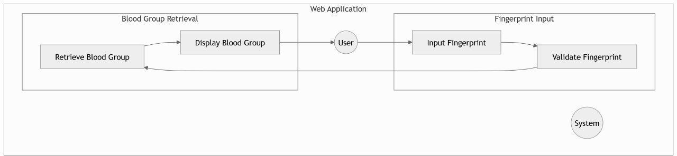
Fig 5.1 Usecase diagram

5.1.2 Class Diagram
A UML class diagram is a visual tool that represents the structure of a
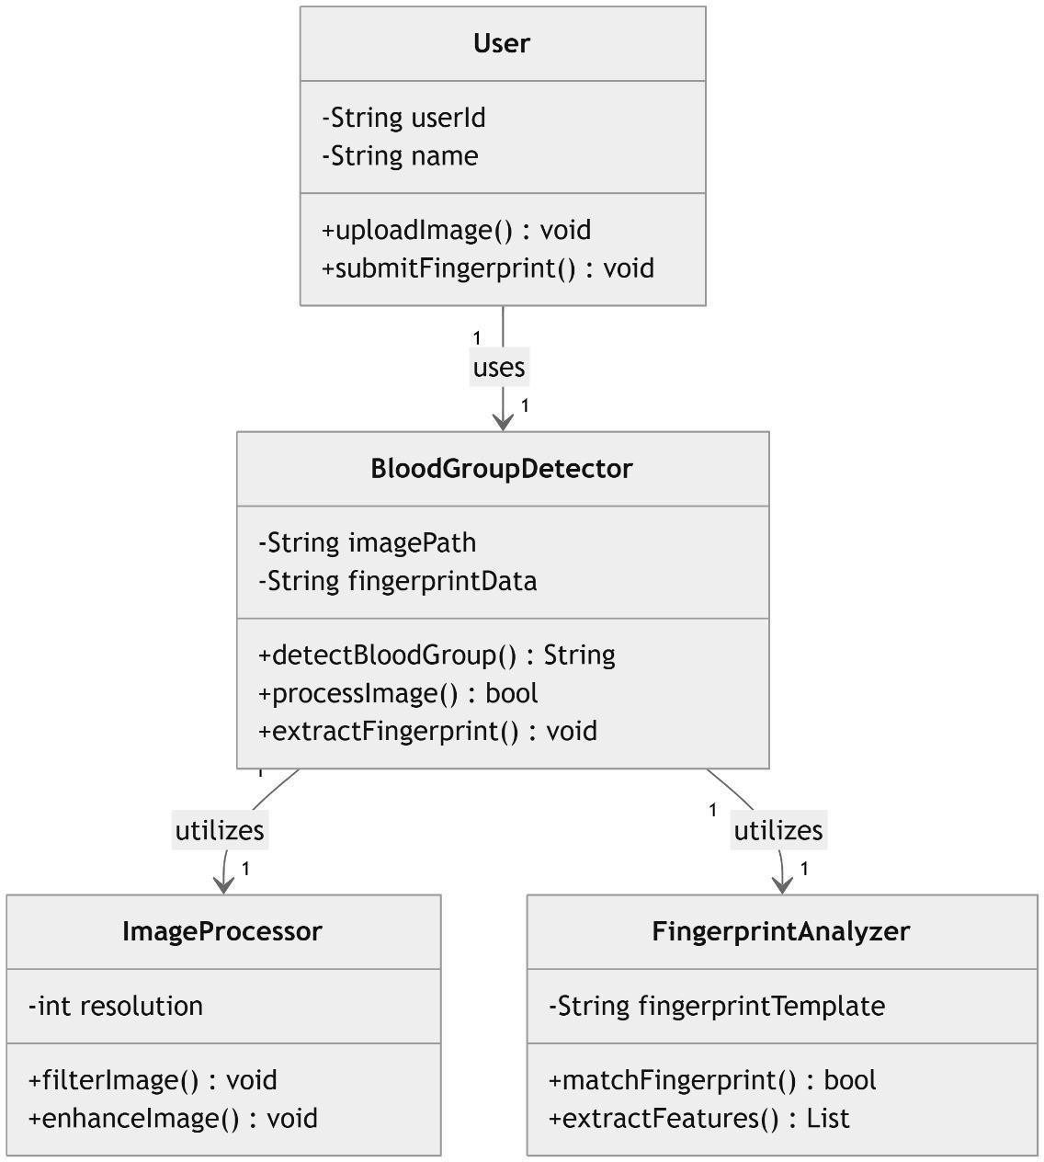
system by showing its classes, attributes, methods, and the relationships between them. It helps everyone involved in a project—like developers and designers—understand how the system is organized and how its components interact.

Fig 5.2 Class Diagram

    - Sequence Diagram
Sequence diagrams describe interactions among classes in term so fan exchange of messages overtime.They're also called event diagrams. A sequence diagram is a good way to visualize and validate various runtime scenarios
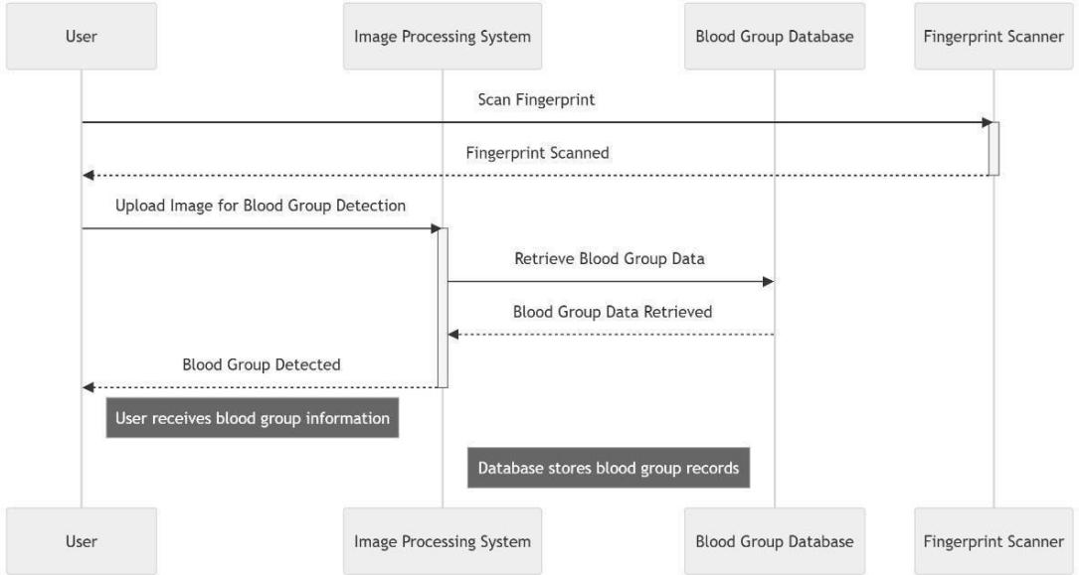

Fig 5.3 Sequence diagram

    - Component Diagram
It shows the relationship between different components in a system. This refers to a module of classes that represent independent systems or subsystems with the ability to interface with the rest of the systems.

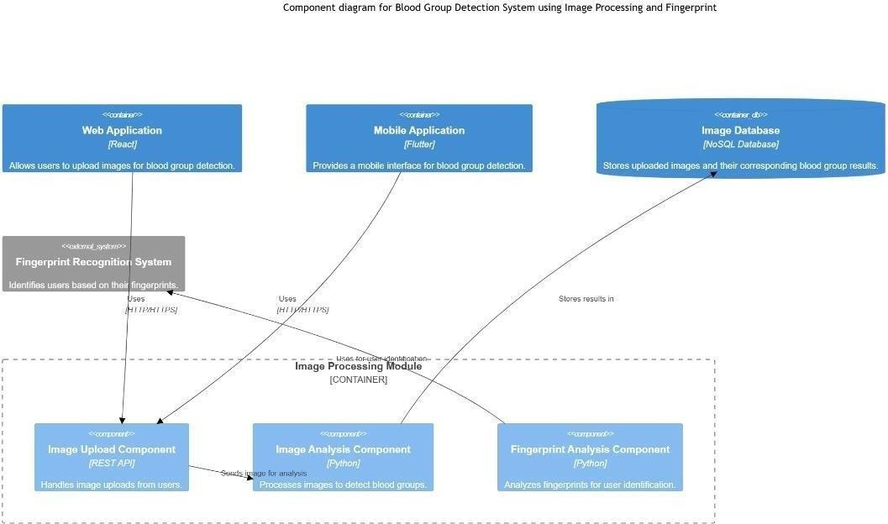
Fig 5.4 Component Diagram

    - State Machine Diagram
It describes the behavior of the system considering all the possible states of an object when an event occurs.
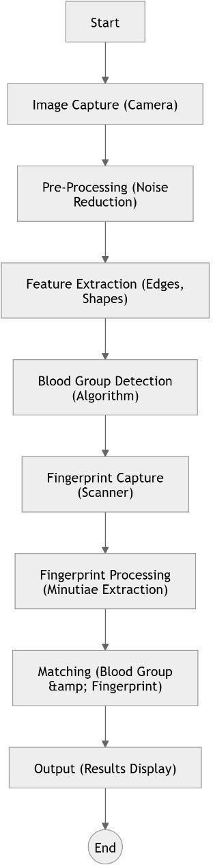
Fig 5.5 State Machine Diagram

CHAPTER - 6
SYSTEM IMPLENTATION

6.1 MODULE DESCRIPTION
The implementation of the proposed fingerprint-based blood group detection system is divided into multiple interdependent modules. Each module is responsible for a distinct function, and their coordinated operation enables the system to achieve its goal of providing accurate, non-invasive blood group predictions using image processing and deep learning techniques. The modular architecture also facilitates ease of testing, maintenance, and future scalability.

6.1.1 Fingerprint Acquisition Module
In conventional biometric systems, fingerprint acquisition typically requires a physical scanner to capture high-resolution images. However, in the proposed system, this module is simulated using a curated fingerprint image dataset sourced from Kaggle. In real-world applications, this module would include hardware such as an optical or capacitive fingerprint scanner capable of capturing intricate ridge and valley structures with at least 500 DPI resolution.
The module ensures consistent image quality by verifying illumination, contrast, and ridge clarity. Images are saved in digital formats such as PNG or JPEG and are validated in real-time to eliminate errors like motion blur, partial prints, or excessive noise. Although this project does not utilize live scanner input, the module conceptually simulates this behavior by validating dataset images for completeness and clarity before further processing.

6.1.2 Preprocessing Module
The preprocessing module plays a crucial role in standardizing input fingerprint images to prepare them for accurate analysis. Raw fingerprint images may vary significantly due to lighting conditions, image quality, or user input inconsistencies. To address this, the module applies the following steps:
- Noise Reduction: Techniques such as Gaussian blur and median filtering are applied to remove background noise while preserving ridge details.
- Histogram Equalization: Enhances global contrast and helps bring out the ridge patterns in low-contrast images.
- Binarization: Converts grayscale images into binary format to differentiate ridges (black) from valleys (white), improving feature extraction precision.
- Resizing and Normalization: All images are resized to 128×128 pixels and normalized (scaled to values between 0 and 1) to ensure uniformity across the dataset and optimize model convergence during training.
The preprocessing pipeline is designed to be fast, efficient, and scalable, implemented using Python libraries such as OpenCV and Pillow within the TensorFlow environment.

6.1.3 Feature Extraction Module
This module is at the heart of the analytical engine. It extracts meaningful features from fingerprint images that are indicative of individual blood group characteristics. Key tasks include:
- Ridge Orientation and Frequency Estimation: Determines the directional flow and spacing of ridges using orientation maps and local frequency analysis.
- Minutiae Detection: Identifies ridge endings, bifurcations, and singular points, which are biologically unique and form the basis of classification.
- Textural Analysis: Gabor filters and Fourier transforms are applied to extract frequency- and orientation-based features, capturing both local and global patterns in the fingerprint image.
The output of this module is a feature vector that serves as the input for the classification model. By focusing on geometric and textural descriptors, the module ensures high fidelity in pattern recognition.

6.1.4 Deep Learning and Classification Module
This module implements the Convolutional Neural Network (CNN) responsible for classifying the extracted features into blood group categories. Key stages include:
- Model Architecture Design: The CNN is composed of multiple convolutional layers with ReLU activation, max-pooling layers for downsampling, and fully connected dense layers for classification.
- Training: The model is trained on the labeled dataset using supervised learning. Categorical crossentropy is used as the loss function, and the Adam optimizer is employed for efficient gradient descent. The model is trained for 20 epochs with real-time validation.
- Evaluation and Tuning: The model is evaluated on a validation set, and hyperparameters such as learning rate, dropout rate, and number of filters are adjusted to optimize performance.
The final trained model outputs one of eight possible blood group predictions with a confidence score, and is saved in .h5 format for deployment.

6.1.5 Verification and Prediction Module
This module verifies the model’s prediction by calculating confidence scores and validating the results against predefined thresholds. Although biometric identification is not part of this system, internal matching of extracted features against model knowledge ensures consistency.
Key operations include:
- Softmax Confidence Filtering: Ensures that predictions are only accepted if their probability exceeds a certain confidence threshold.
- Error Handling: Manages cases where the model produces low-confidence outputs or ambiguous classifications.
- Output Normalization: Converts one-hot encoded model outputs into human-readable blood group predictions (e.g., “A+”, “O−”).
This module adds an additional layer of reliability and can be expanded in future versions to incorporate multi-model ensembles or cross-verification mechanisms.

6.1.6 User Interface Module
This module provides a user-friendly, web-based interface that allows users to upload fingerprint images, initiate prediction, and view results. Built using React.js, the interface includes:
- Image Upload Feature: Users can browse and select fingerprint image files.
- Prediction Button: Sends the image to the Flask backend via Axios POST request.
- Result Display Panel: Shows the predicted blood group, prediction confidence, and optionally, system logs or history.
The interface is designed to be lightweight, responsive, and compatible across devices and browsers. It includes visual feedback for loading states, error messages, and result confirmation, ensuring usability for users with minimal technical expertise.

6.1.7 Database Management Module
This module handles the storage of all essential data, including prediction results, timestamps, and optionally, processed fingerprint metadata. Implemented using MySQL, it features:
- CRUD Functionality: Enables creation, retrieval, updating, and deletion of records as needed.
- Secure Data Handling: Implements input sanitization and database indexing to prevent SQL injection and optimize queries.

6.1.8 Scalability and Maintenance Module
This module ensures that the system remains responsive and maintainable as usage increases or as new features are added. Features include:
- Modular Architecture: Each component is built independently and can be upgraded without affecting the rest of the system.
- Horizontal Scaling: The backend can be deployed on multiple servers to handle increasing requests.
- Logging and Monitoring: Tracks errors, API performance, and user interactions to detect performance bottlenecks or bugs.
- Auto-Backup and Failover Support: In future iterations, the system can incorporate automated database backups and fault-tolerant infrastructure.
This module makes the system future-proof and ready for integration into high-traffic environments.

6.1.9 Testing and Evaluation Module
Robust testing is critical for ensuring system reliability. This module includes:
- Unit Testing: Verifies that individual modules (e.g., model loader, API handler, image preprocessor) function correctly in isolation.
- Integration Testing: Checks that components work together correctly from image upload to database logging.
- Performance Testing: Measures response times, model inference time, and accuracy under different hardware constraints.
- User Acceptance Testing (UAT): Real users evaluate the system in realistic scenarios to provide feedback on usability, accuracy, and performance.
Test results are logged and analyzed to improve the system prior to deployment.

6.1.10 Deployment and Training Module
This final module ensures that the system is delivered and made usable by its intended audience. It involves:
- Installation and Configuration: Setting up the Flask server, frontend environment, and MySQL database on deployment machines.
- User Documentation: Providing manuals, online help files, or walkthrough videos to guide users.
- Training Sessions: Conducting hands-on sessions to familiarize users or clients with the system.
- Post-Deployment Support: Offers issue tracking, bug fixes, and feature updates based on feedback..

CHAPTER - 7
SYSTEM TESTING

7.1 OBJECTIVE OF SYSTEM TESTING
The primary objectives of system testing for this project were:
- To validate the functionality of the fingerprint image upload, backend communication, and blood group prediction.
- To ensure the system can handle different image formats, sizes, and resolutions without failure.
- To test the reliability, accuracy, and response time of the prediction model when accessed via the frontend.
- To evaluate the system’s ability to gracefully handle invalid input, missing files, or server errors.
- To confirm that the user interface responds correctly and displays prediction results without lag or confusion.

7.2 TESTING ENVIRONMENT
The testing was conducted in the following environment:
- Operating System: Windows 10 (64-bit)
- Browser: Google Chrome, Mozilla Firefox
- Development Tools: Visual Studio Code, Google Colab, MySQL Workbench, Postman
- Model Deployment: Local Flask server with ngrok tunneling for public access
- Hardware: NVIDIA-enabled laptop (GPU support for model training and testing)

7.3 TEST CASE FLOW DESCRIPTION
The complete user interaction flow tested during the system run is as follows:
- Choose File: The user selects a fingerprint image from their local device using the "Choose File" button.
- Click Submit: The user clicks the "Submit" or "Predict" button, triggering an API call from the React frontend to the Flask backend.
- Image Preprocessing: On the backend, the image is resized, normalized, and prepared for model inference.
- Prediction: The trained CNN model processes the image and outputs a probability distribution over 8 blood group classes.
- Response: The backend returns the predicted blood group (e.g., "A+", "B−") in JSON format.
- Result Display: The frontend receives the response and displays the predicted blood group clearly to the user.
Each step in the above workflow was tested for correctness, error handling, and user-friendliness.

7.4 UNIT TESTING
Each functional component was tested independently:
- Image Upload Component: Verified that valid image files (.jpg, .png, .jpeg) can be selected and passed to the backend.
- Flask API: Confirmed that the /predict endpoint properly receives the image, performs inference, and returns the predicted blood group.
- CNN Model: Tested for accuracy using a batch of known inputs to ensure consistent classification.
- Frontend Display: Validated that the correct blood group is displayed and that loading indicators and error messages appear appropriately.
- Node.js Logging: Verified successful storage of predictions in the MySQL database with correct timestamps.

7.5 INTEGRATION TESTING
Integration testing validated the interaction between the frontend, backend, and model:
- A fingerprint image was uploaded through the browser interface.
- The image was received by the Flask backend, processed, and passed through the CNN model.
- The predicted output was successfully sent back to the frontend and displayed.
- The same result was logged into the database via the Node.js service.
This end-to-end process was tested using multiple image samples for each blood group, ensuring that the system performed well under repeated use.

7.6 PERFORMANCE TESTING
The system’s responsiveness and efficiency were tested:
- Prediction Time: The time from image submission to result display was consistently under 2 seconds, indicating a fast and efficient prediction pipeline.
- Concurrent Access: Multiple users tested the system simultaneously, and no noticeable lag or crashes occurred.
- Image Size Tolerance: Images up to 2MB were tested, and the system handled them without performance degradation after resizing and preprocessing.

7.7 VALIDATION TESTING WITH DATASET SAMPLES
To further test the model’s real-world usability, fingerprint images from the original Kaggle dataset were uploaded through the frontend one at a time. Each result was compared with the known label to evaluate frontend-model integration accuracy. The system consistently matched the model’s offline predictions, proving that deployment did not affect reliability.

7.8 ERROR HANDLING AND ROBUSTNESS TESTING
The system was tested for how it handles edge cases:
- No File Selected: Submitting without selecting a file triggers an appropriate error message.
- Invalid File Type: Uploading non-image files (e.g., .txt, .pdf) resulted in a validation error.
- Server Unavailable: If the Flask server was offline, the frontend displayed a connection error.
- Image Corruption: Blurry or cropped fingerprint images were either rejected or returned lower confidence scores.
These tests confirmed that the system fails gracefully and does not crash or behave unpredictably

7.9 USER EXPERIENCE AND INTERFACE TESTING
The UI was tested for intuitiveness and responsiveness:
- Buttons were clearly labeled ("Choose File", "Predict").
- Progress indicators showed when the system was processing.
- Prediction results were displayed prominently in large text.
- Mobile and desktop browser testing confirmed full responsiveness.
Feedback from users indicated that the interface was clean and easy to understand, even for those without a technical background.

CHAPTER - 8
CONCLUSION
The fingerprint-based blood group detection system is an innovative and efficient approach to simplifying the traditionally invasive and time-consuming blood group determination process. By leveraging advanced image processing techniques, machine learning algorithms, and a user-friendly interface, the system offers a non-invasive, quick, and accurate method to identify blood groups. Each module, from fingerprint scanning to deployment, is designed to ensure reliability, scalability, and ease of use, making the system practical for diverse applications such as healthcare, emergency response, and blood donation camps. With proper testing, training, and deployment, this system has the potential to revolutionize how blood group identification is performed, providing significant benefits for both medical professionals and individuals.

CHAPTER-9 APPENDIX

A:SOURCE CODE
A1:DatasettrainingandTestingcode(python):

- !pipinstalltensorflow

- import tensorflow as tf print("NumGPUsAvailable:",
len(tf.config.list_physical_devices('GPU')))

- fromgoogle.colabimportdrive drive.mount('/content/drive')
- importos

dataset_path='/content/drive/MyDrive/dataset_blood_group'print(os.listdir(dataset_path))
- #Step2:ImportLibraries

importos

importtensorflowastf import numpy as np
importmatplotlib.pyplotasplt
from tensorflow.keras.preprocessing.image import ImageDataGenerator # Step 3: Define Paths (Update with your actual dataset path) dataset_path="/content/drive/MyDrive/dataset_blood_group"#Change this path accordingly

# Step4:Image Preprocessing
img_size=(128, 128)
batch_size= 32
datagen=ImageDataGenerator( rescale=1./255,
validation_split=0.2,#80%Train,20%Validation rotation_range=20,
zoom_range=0.2, horizontal_flip=True
)
train_data=datagen.flow_from_directory( dataset_path,
target_size=img_size, batch_size=batch_size, class_mode='categorical', subset='training'
)
val_data=datagen.flow_from_directory( dataset_path,
target_size=img_size, batch_size=batch_size,
class_mode='categorical', subset='validation'
)

#Step5:DefineCNN Model
model = tf.keras.models.Sequential([ tf.keras.layers.Conv2D(32,(3,3),activation='relu',
input_shape=(128, 128, 3)), tf.keras.layers.MaxPooling2D(2,2), tf.keras.layers.Conv2D(64, (3,3), activation='relu'), tf.keras.layers.MaxPooling2D(2,2), tf.keras.layers.Conv2D(128,(3,3),activation='relu'), tf.keras.layers.MaxPooling2D(2,2), tf.keras.layers.Flatten(),
tf.keras.layers.Dense(128, activation='relu'), tf.keras.layers.Dropout(0.5), tf.keras.layers.Dense(train_data.num_classes,activation='softmax')
])
# Step 6: Compile the Model model.compile(optimizer='adam', loss='categorical_crossentropy', metrics=['accuracy'])
#Step7:TraintheModel
epochs=20#Adjustbasedonperformance
history=model.fit(train_data,validation_data=val_data, epochs=epochs)
# Step 8: Save the Modelmodel.save ("/content/drive/My Drive/dataset_blood_group/blood_group_model.h5") # Step 9: Evaluate Model
acc = history.history['accuracy']
val_acc = history.history['val_accuracy'] plt.plot(acc, label='Training Accuracy') plt.plot(val_acc,label='ValidationAccuracy') plt.legend()
plt.show()

#Step10:LoadandTestModel
fromtensorflow.keras.preprocessingimportimage def predict_blood_group(img_path):
img=image.load_img(img_path,target_size=img_size) img_array = image.img_to_array(img) / 255.0 img_array = np.expand_dims(img_array, axis=0) prediction = model.predict(img_array)
class_names=list(train_data.class_indices.keys()) return class_names[np.argmax(prediction)]
# Example: Predict a single image (Change the path to an actual image) test_image_path = "/content/drive/MyDrive/dataset_blood_group/A+/test1.jpg"print("PredictedBloodGroup:",predict_blood_group(test_image_path))
- from tensorflow.keras.preprocessing.image import ImageDataGenerator
train_dir='/content/drive/MyDrive/dataset_blood_group' datagen = ImageDataGenerator(rescale=1./255) train_data = datagen.flow_from_directory(
train_dir, target_size=(150,150), batch_size=32,
class_mode='categorical'#or'binary'ifonly2classes
)
print("Detected Classes:",train_data.class_indices)
from tensorflow.keras.models import Sequential
fromtensorflow.keras.layersimportConv2D,MaxPooling2D,Flatten,
Dense,
Dropout model=Sequential([
Conv2D(32,(3,3),activation='relu',input_shape=(150,150,3)),
MaxPooling2D(pool_size=(2,2)),

Conv2D(64,(3,3),activation='relu'),
MaxPooling2D(pool_size=(2,2)), Flatten(),
Dense(128,activation='relu'), Dropout(0.5),
Dense(4,activation='softmax')#4classes:A,B,AB,O

])

model.compile(optimizer='adam', loss='categorical_crossentropy', metrics=['accuracy'])
- val_dir='/content/drive/MyDrive/dataset_blood_group' val_data = datagen.flow_from_directory(
val_dir, target_size=(150, 150), batch_size=32, class_mode='categorical'
)
- model=Sequential([
Conv2D(32,(3,3),activation='relu',input_shape=(150,150,3)),

MaxPooling2D(pool_size=(2,2)),
Conv2D(64,(3,3),activation='relu'),
MaxPooling2D(pool_size=(2,2)), Flatten(),
Dense(128,activation='relu'), Dropout(0.5),
Dense(8,activation='softmax')#✅8classes,not4
])
- model.compile(optimizer='adam', loss='categorical_crossentropy', metrics=['accuracy'])
history=model.fit(train_data,validation_data=val_data,epochs=20, callbacks=[early_stop])
- !pipinstallflaskflask-corstensorflow
- importos
saved_model_path = "/content/drive/My Drive/dataset_blood_group/blood_group_model.h5"print(os.path.exists(saved_model_path))#ShouldprintTrueifmodel is saved
- fromtensorflow.keras.modelsimportload_model model = load_model("/content/drive/My Drive/dataset_blood_group/blood_group_model.h5")
- model=tf.keras.models.load_model(
"/content/drive/MyDrive/dataset_blood_group/blood_group_model.h5", compile=False
)15.def predict_blood_group(img_path):
img=image.load_img(img_path,target_size=(128,128)) img_array = image.img_to_array(img) / 255.0
img_array = np.expand_dims(img_array, axis=0) prediction = model.predict(img_array) class_names=list(train_data.class_indices.keys()) return class_names[np.argmax(prediction)]
#Exampletest
test_image_path = "/content/drive/MyDrive/dataset_blood_group/A+/cluster_0_1026.BMP"print("Predicted Blood Group:", predict_blood_group(test_image_path))
16.importos
print(os.listdir())17.fromflaskimportFlask,request,jsonify import tensorflow as tf
fromtensorflow.keras.preprocessingimportimage import numpy as np
importos
fromflask_corsimportCORS

app=Flask( name ) # <-- fix _name_ to name

CORS(app)
#Updatedpathtomodel
model=tf.keras.models.load_model("/content/drive/My Drive/dataset_blood_group/blood_group_model.h5")
class_names=['A+','A-','B+','B-','AB+','AB-','O+','O-']
@app.route('/predict',methods=['POST']) def predict():
if'file'notin request.files:
returnjsonify({'error':'Noimageuploaded'}),400 file = request.files['file']
img_path=os.path.join('temp.jpg') file.save(img_path)
img=image.load_img(img_path,target_size=(150,150)) img_array = image.img_to_array(img) / 255.0
img_array=np.expand_dims(img_array,axis=0) prediction = model.predict(img_array)
predicted_class=class_names[np.argmax(prediction)] return jsonify({'blood_group': predicted_class})
# Fix name typo
if name ==' main ':
app.run(debug=True,port=5000)PythonFlask((Backend):
!pip install flask flask-cors pyngrok fromflaskimportFlask,request,jsonify from flask_cors import CORS
importtensorflowastf import numpy as np
From tensorflow.keras.preprocessing import image from pyngrok import ngrok
Import os
#Loadthemodel model =
tf.keras.models.load_model("/content/drive/MyDrive/dataset_blood_grou p/
blood_group_model.h5")
class_names=['A+','A-','B+','B-','AB+','AB-','O+','O-']

app = Flask( name ) CORS(app)
@app.route('/predict',methods=['POST']) def predict():
if'file'notin request.files:
returnjsonify({'error':'Noimageuploaded'}),400 file = request.files['file']
file.save("temp.jpg")
img=image.load_img("temp.jpg",target_size=(128,128)) img_array = image.img_to_array(img) / 255.0
img_array=np.expand_dims(img_array,axis=0) prediction = model.predict(img_array)
predicted_class=class_names[np.argmax(prediction)]
returnjsonify({'blood_group':predicted_class})
#OpentheFlaskappviangrokpublic_url=ngrok.connect(5000) print(f"Flask app is live at: {public_url}")
app.run(port=5000)
9.1.2 React.js
importReactfrom'react';
Import Blood GroupDetector from'./Blood Group Detector'; import './App.css';
functionApp(){ return (
<divclassName="App">

<h1>BloodGroupDetectionusingFingerprint</h1>
<BloodGroupDetector/>
</div>

);
}

exportdefault App;

bloodgroupdetector.js(src—>file):
//BloodGroupDetector.js
importReact,{useState}from'react'; import axios from 'axios';
import'./App.css';
function BloodGroupDetector() { const[file,setFile]=useState(null);
const[prediction,setPrediction]=useState(''); const [loading, setLoading] = useState(false); const [error, setError] = useState('');
consthandleUpload=async()=>{ if (!file) {
setError("Pleaseselectanimage."); return;
}
setLoading(true); setError(''); setPrediction('');
constformData=newFormData(); formData.append('file', file);
try{
//SendtoPythonbackendforprediction const response = await
axios.post('https://339b-34-19-106-48.ngrok-free.app/predict', formData);
constpredictedGroup=response.data.blood_group;

setPrediction(predictedGroup);
//SendtoNodebackendforstorage

awaitaxios.post('http://localhost:3001/store',{blood_group: predictedGroup });
}catch (err) {

setError('Error while uploading or processing.Checkserver.');
} finally { setLoading(false);
}

};
return(
<divclassName="detector-container">

<inputtype="file" accept="image/*"
onChange={e=>setFile(e.target.files[0])} className="file-input"
/>

<buttononClick={handleUpload}className="upload-button">
{loading?'Predicting...':'Predict'}
</button>

{prediction&&<h2className="result">PredictedBloodGroup:
{prediction}</h2>}
{error&&<pclassName="error">{error}</p>}

</div>
);
}

export default BloodGroupDetector; Package.json(addatlastcurlbraces) "proxy": "http://localhost:5000"
A2:App.css

/*App.css*/
.App{

text-align:center; padding: 40px;
font-family:'SegoeUI',Tahoma,Geneva,Verdana,sans-serif; background-color: #f2f2f2;
min-height:100vh;
}
h1{

color:#333;
margin-bottom:30px;
}

.detector-container{
display:flex;
flex-direction:column; align-items: center;
}
.file-input { padding:10px;
margin-bottom:20px; font-size: 16px;}
.upload-button { padding:10px20px;
background-color:#007bff; border: none;
color: white; font-size:16px; cursor: pointer;
border-radius:5px;
}
.upload-button:hover { background-color:#0056b3;
margin-top:20px; font-size: 20px;
}

margin-top:15px;

9.1.2node.js(backend data to store) A3 : index.js
//index.js

constexpress=require('express'); const cors = require('cors');
constbodyParser=require('body-parser'); const mysql = require('mysql2');
constapp=express(); const port = 3001;
app.use(cors());app.use(bodyParser.json());
//MySQLconnectionsetup
constdb=mysql.createConnection({ host: 'localhost',
user:'root',
password:'root',//change this

database:'blood_group_db'//makesurethisDBexists
});
db.connect(err=>{ if (err) {
console.error('MySQLconnectionerror:',err);
}else {

console.log('ConnectedtoMySQL');

}
});

//Createtableifnotexists db.query(`
CREATETABLEIFNOTEXISTSpredictions( id INT AUTO_INCREMENT PRIMARY KEY,
blood_groupVARCHAR(10),
predicted_atTIMESTAMPDEFAULTCURRENT_TIMESTAMP
)

`);
//APIendpointtostoreprediction app.post('/store', (req, res) => { const{blood_group}=req.body; if (!blood_group) {
returnres.status(400).json({error:'Bloodgroupisrequired'});

}
constquery='INSERTINTOpredictions(blood_group)VALUES(?)'; db.query(query, [blood_group], (err, result) => {
if (err) {
console.error('Error storing data:', err); res.status(500).json({error:'Failedtostorebloodgroup'});
}else {

res.status(200).json({message:'Bloodgroupstoredsuccessfully'
});
}

});
});
app.listen(port,()=>{

console.log(`Nodeserverrunningonhttp://localhost:${port}`);
});
A4:Mysql

CREATEDATABASEIFNOTEXISTSblood_group_db; USE blood_group_db;
CREATETABLEIFNOTEXISTSpredictions( id INT AUTO_INCREMENT PRIMARY KEY,
blood_groupVARCHAR(10),
predicted_atTIMESTAMPDEFAULTCURRENT_TIMESTAMP

);

B: SCREENSHOTS
B1:MySql workbench
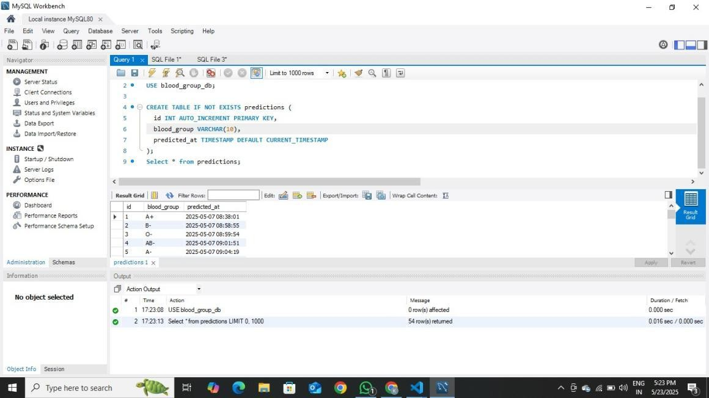

B2:Visual Studio code(frontend and backend code)
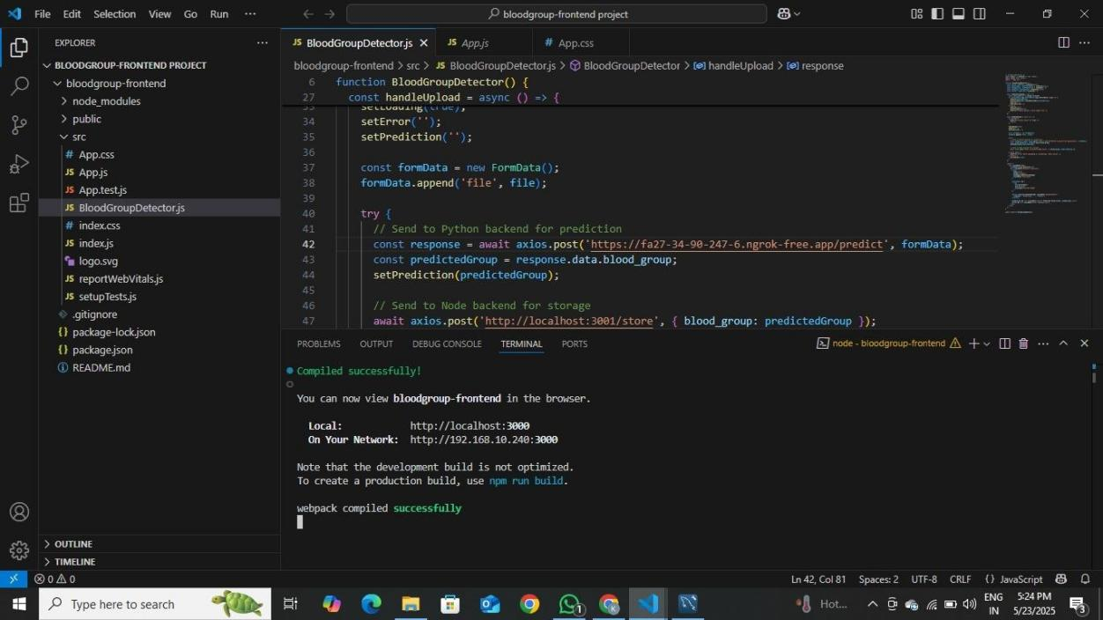

B3:Googlecolab for training
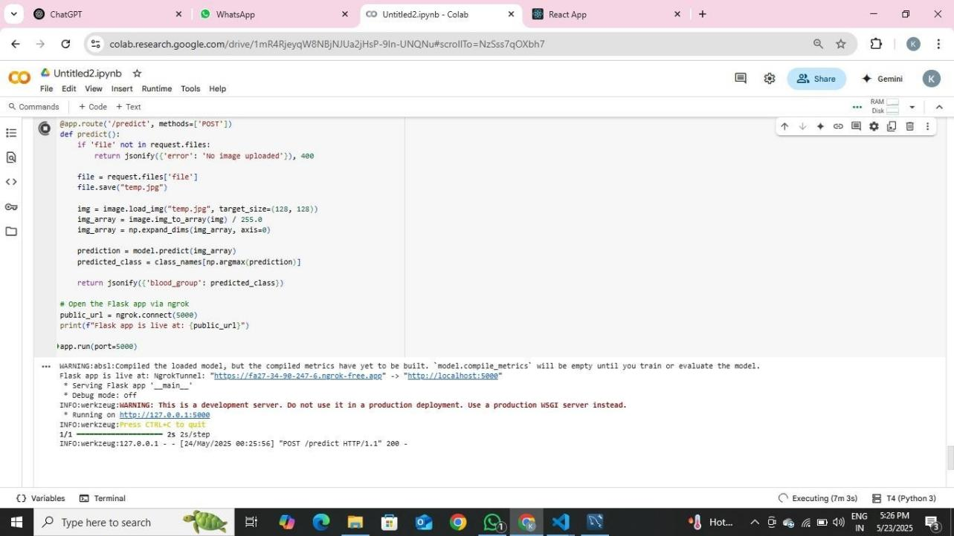

B4:File select
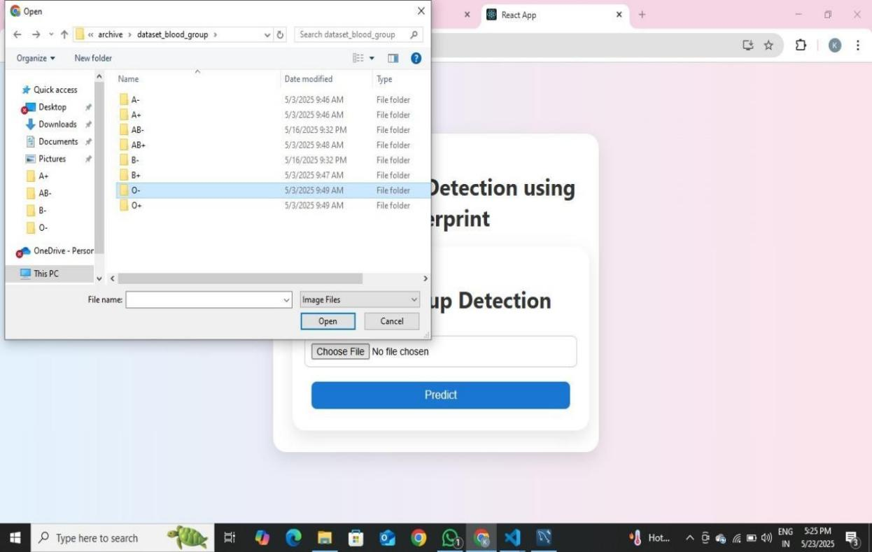

B5:Input
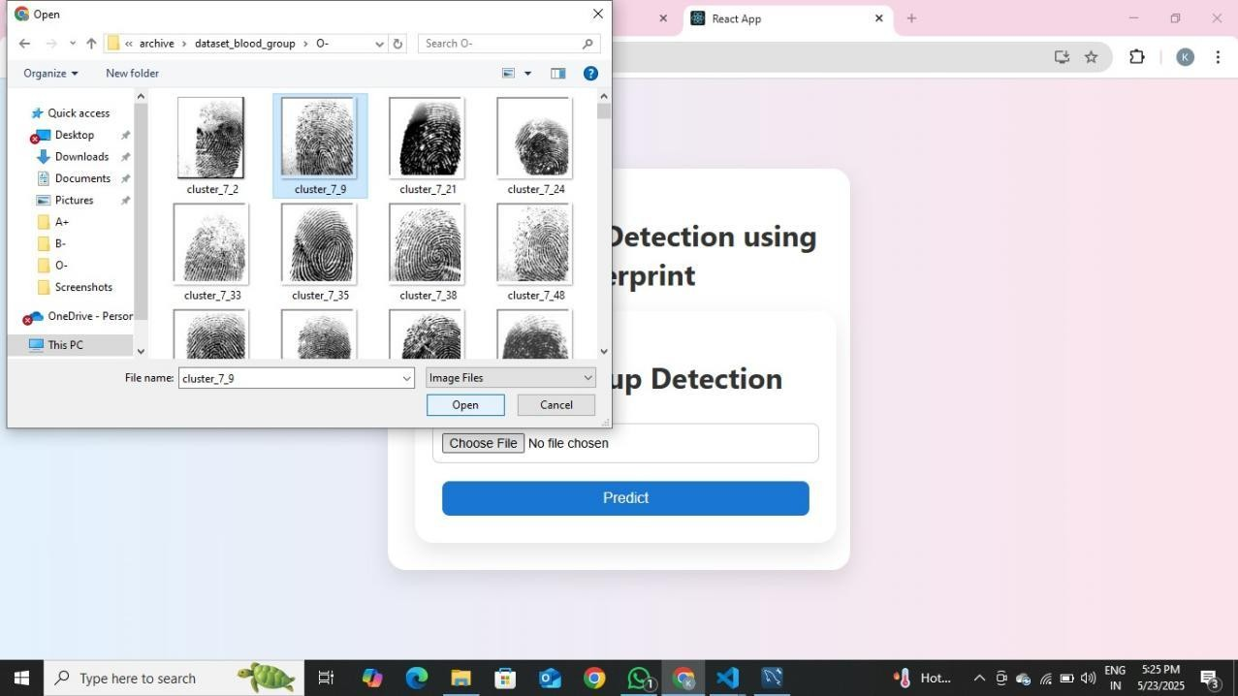

B6:Bloodgroup prediction output1
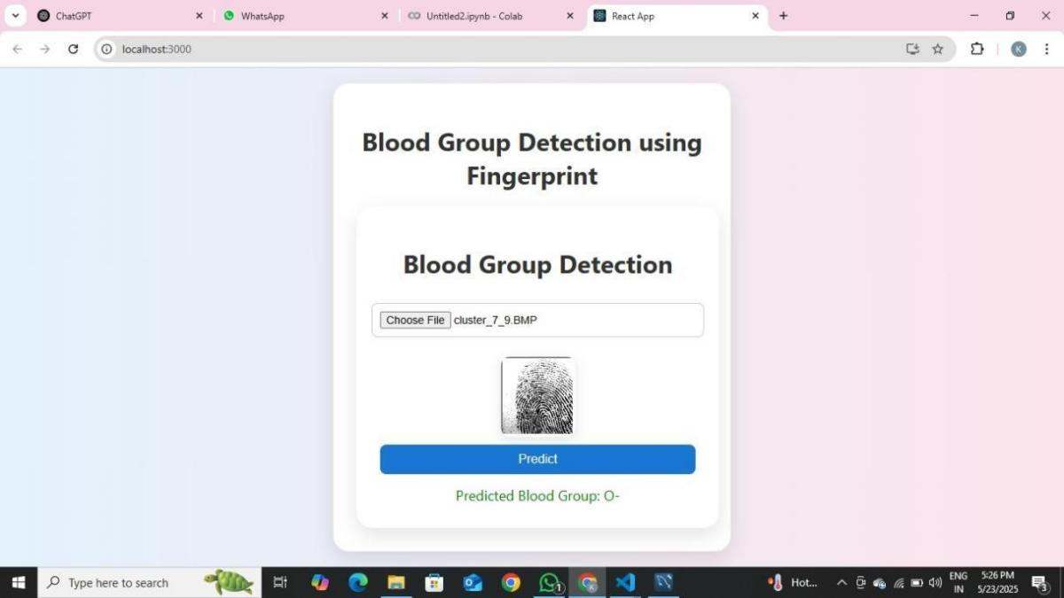

B7:Blood group prediction output2
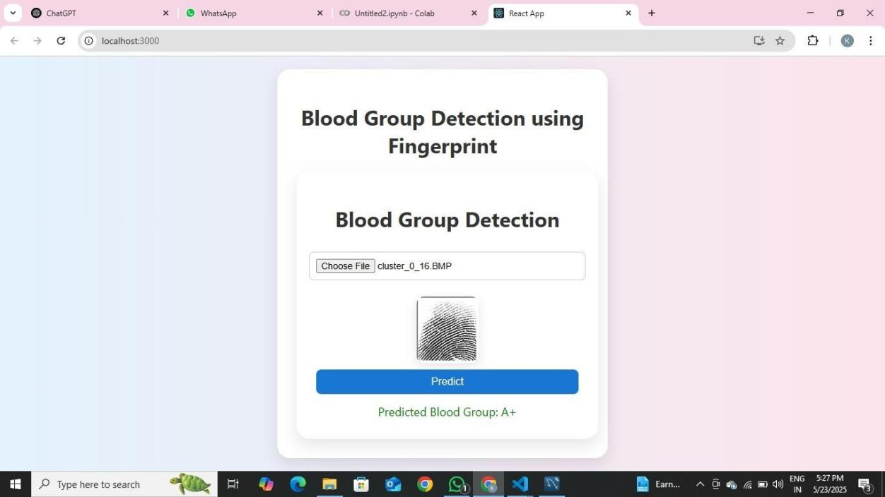

CHAPTER - 10
REFERENCES
- Agarwal,P.,&Singh,R.(2024).FingerprintAnalysisforBlood Group Detection. MATECWeb of Conferences, 392, 01069.
https://doi.org/10.1051/matecconf/202439201069
- IEEExpert.(n.d.).Bloodgroupdetectionusingfingerprintwith image processing. Retrieved December 11, 2024, from https://www.ieeexpert.com/python-projects/blood-group-detection-using-fingerprint-with-image-processing/

- T.Nihar, K.Yeswanth, &K.Prabhakar.(2024). Bloodgroup determination using fingerprint.MATEC Web of Conferences. https://doi.org/10.1051/matecconf/202439201069
- Khan, F., & Kumar, A. (2023). Correlation of Fingerprint Patterns and Blood Groups: A Statistical Analysis. IEEE Transactions on Biomedical Engineering, 70(11), 2999-3010. https://doi.org/10.1109/TBME.2023.3216542

